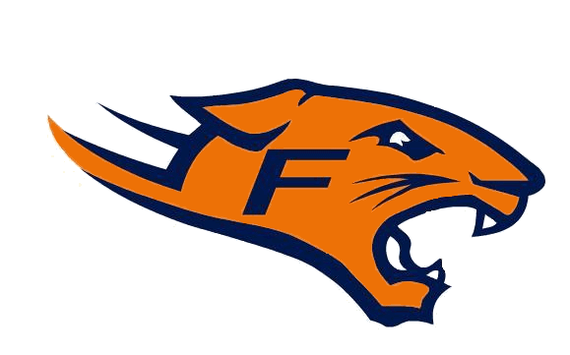 Fallston Cougars Football 2012

MEETING MINUTES
May 2012

Secretary Report
- Meeting minutes and Meeting agendas will be posted on the website; there will be no more mass emails.

UCYFL
- There will be two divisions for the 2012 Season
- Football Season will begin on August 1, 2012
- Next meeting June 3, 2012

Fallston Rec. Council Report
- The Rec. Council is looking into purchasing a lightening detector device
- Looking into grooming of the Turf
- Officers were elected, they will serve a 2 year term

Treasurer’s Report
- Ted handed out Budget sheet

Concessions Report
- Still need at least 3 more volunteers to help on Concession Committee
- Contacting local businesses for donations of items for the concession stand

Equipment Report

- Equipment hand out will Start soon, please refer to the website for your age groups pick up date

Old Business
- Frostburg; not required, but is encouraged; August 3rd, 4th, and 5th.
- Bull Roast will take place on November 10, 2012 at the Richlin Ballroom; Details to follow
- Looking for a 10U white head coach; if interested contact Ian Mitchell, this is an appointed position decided by the BOD.
- Still need volunteers for the following; Player Liaison and Cheerleading Liaison. If interested please email Jodi Juliano at secretary@fallstonfootball.com

New Business

- Looking into having a Football Camp

Adjournment

Next meeting is June 21, 2012 at 7:00pm

