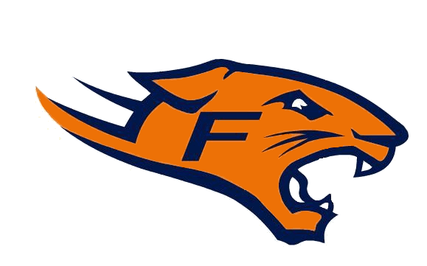 Fallston Cougars Football 2012

MEETING MINUTES
January 2012

Chairman’s Report from Fallston Rec. Meeting

- Advertisements and Banners are available to purchase for the Bowl or the scoreboards at the Chenowith Center. If interested contact Fallston Rec. Council

UCYFL
- 8U- will play 10 minute Quarters, there will be no more play count and they will play 100 yard field.
- 14U- No High School Students. Players will play unlimited weight with no restrictions.
- Perry Hall and Towson want to join UCYFL.
- As of 2013, no more OBL, age only.
- There will be no YBH, it will be straight tackle to tackle. There will be no limit to the number of plays.

Treasurer’s Report

- Ted and Ian are in the process of putting together the February budget.

Concessions Report

- For the 2012 season, the home team will cover concession duty immediately following their game. Coaches will man the grill. The team that has the last game of the night will have concession duty for the first game.
- Clinic teams will be responsible for Friday night games, this is subject to change.
Equipment Report

- 100 Helmets need to be replaced.
- All players will need to purchase a girdle; we will only provide knee pads.
We will be selling girdles at weigh in and equipment pick up.

New Business
- Coaches’ elections will take place at the Feb. 16th meeting.
- Registration will take place online only. Returning players registration will open around Feb. 1st and new players will be able to register approximately 10 days later.
- Weigh dates will be decided at the February meeting.
- Jodi Juliano was elected as Secretary for 2012.
- Iron Birds night- Still gathering information
- Jersey Numbers- The player that is in the correct age group, will have the right to their jersey number, in the case that there is two players in the correct age group with the same number, the first one to register will get their number.

Coaches Nominations:
As of Jan. 19th
6U- Steve Schneiders
6U -
7U- Jim Dickens
7U – Matt Rohlfling
8U Orange -
8U Blue - Lou Holcomb, Scott Reichard
9U Orange – Chris Erhardt
9U Blue – Chris Tutas, Scott Dennis
10U Orange – Todd Ford, Chip Pross, Bob Diem
10U Blue – Neil Maria
11U Orange – Eric Andrews
11U Blue – Jamie Herbert
12U Orange – John Appleby
12U Blue – Brooks Poulsen
14U Orange – Pete Moriarity
14U Blue – Toby Tucker
These nominations are open until January 31st and voted on at the February Meeting.

Please remember nominations can only be made by a member with voting rights.

Adjournment – Next Meeting February 16, 2012 at the Chenowith Center

